Fernando Gonzales-Vigil

Project 3

**Test Plan**

|  |  |  |  |  |  |
| --- | --- | --- | --- | --- | --- |
| **Test Case #** | **Input** | **Actual input** | **Expected Output** | **Actual Output** | **Did Test Pass?** |
| 1 | Can you drive if the light is red? / Answer N | same | Accept and ask if more question will be asked | Do you have more questions to enter | YES |
| 2 | Question longer than 70 characters | “Can you drive if there’s a midget…” | Reject answer because of length | “Question longer than 70 chars” | YES |
| 3 | 2 Questions to a file test.txt | same | Create file test.txt | File created | YES |
| 4 | Age below 16 | Birth year 2005 | No access to exam | “You have no age for a driver’s license” | YES |
| 5 | Non existent txt file | Runner.txt | Incorrect file | “The selected file is not correct or is incomplete” | YES |
| 6 | Correct Input | Correct answers | Exam Passed 10/10 | “Congratulations, you passed the exam” | YES |

*Yellow Cells are values by user input

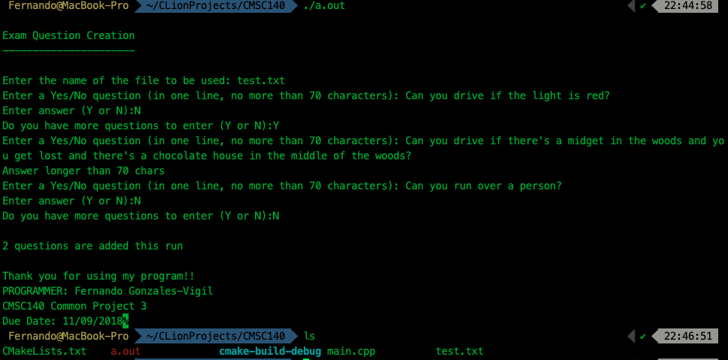

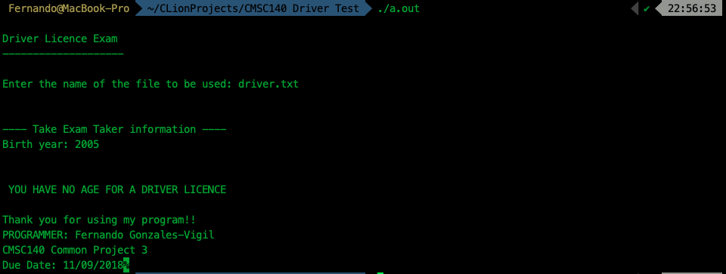

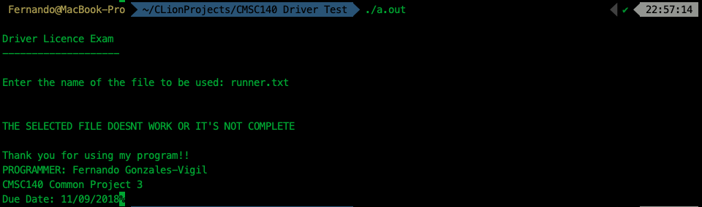

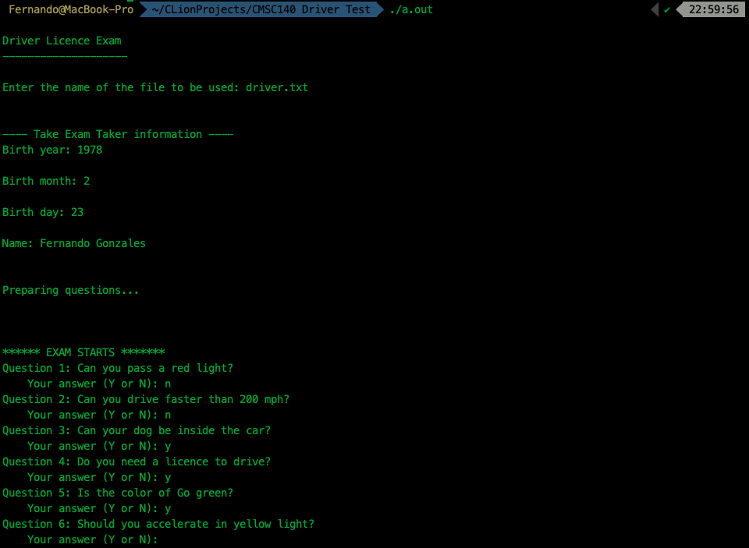

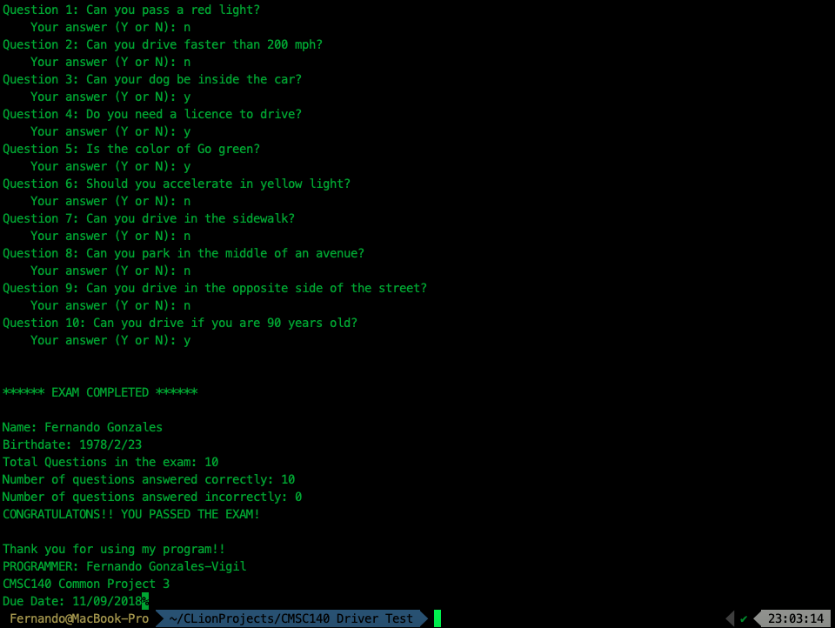

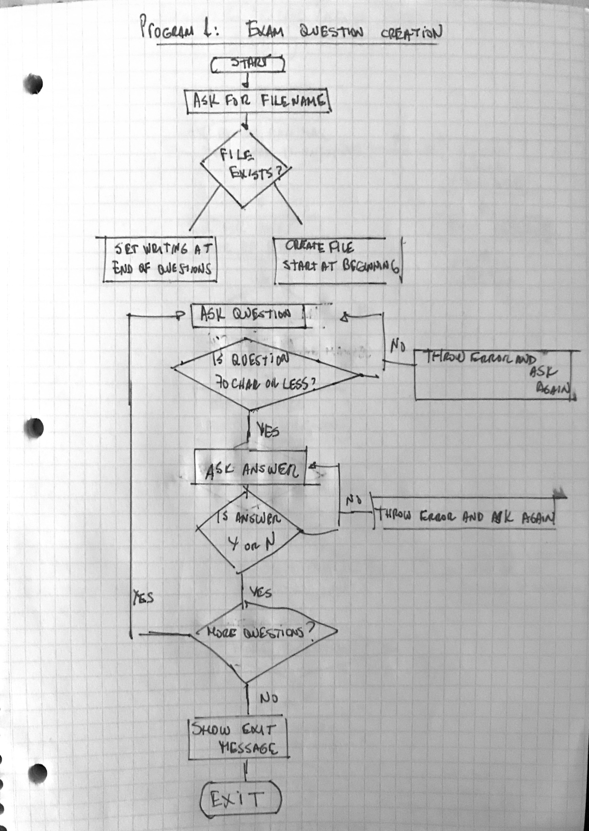

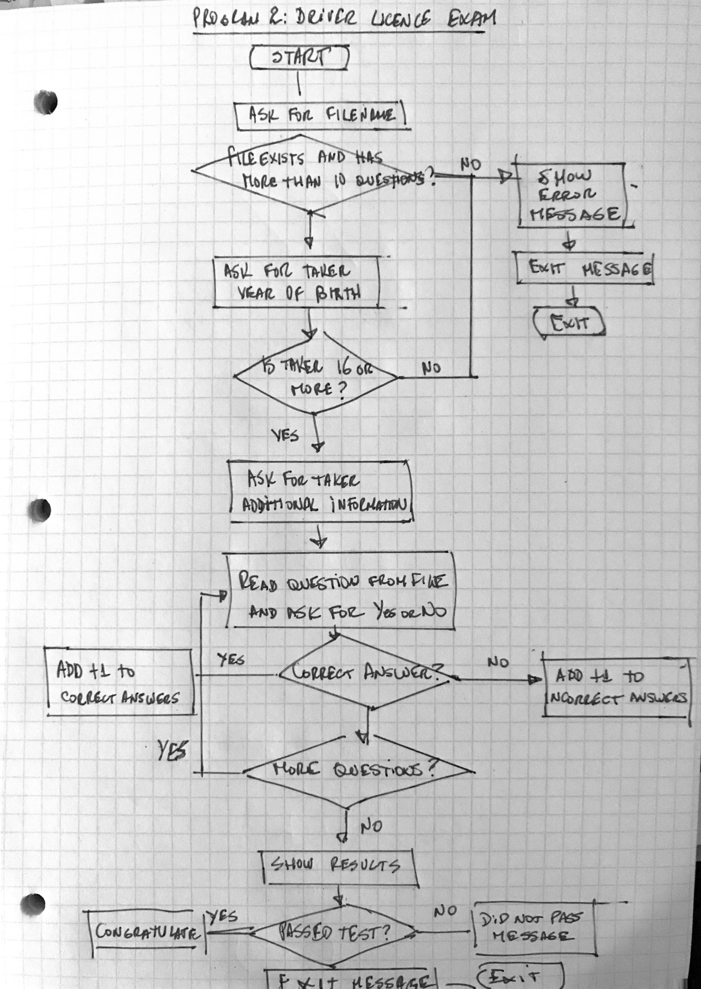

Lesson Learned:

* When working with files, once you read a file and reach the end of file, you have to close it and open it again if you want to read it, otherwise, getline doesn’t get more line since you reached eof (end of file).
* Instead of using:

ofstream file;

file.open(filename);

You can simple use this:

ofstream file(filename);

* You can add ios::app after the filename, like this:

Ifstream file(filename, ios::app) so you can append data at the end of the file if the file already exists. This way you avoid overwriting or creating new files, each time.